April 13, 2026
nocturnals
Miguel cuon, Damon Corso, Michael dodd
Dreamscape System Requirements Document
DRAFT
Table of Contents
Introduction 2
Description Model 2
Class Diagram 4
Use Case Diagram 4
Use Case Scenarios 5
System Sequence Charts 5

Introduction (MD)
This document is dedicated to describing and visualizing the different requirements, functions, classes, and systems that are used in Dreamscape. This document gives an in-depth text summary using a description model. Additionally, it provides a visualization of classes used within Dreamscape’s code, including system objects, attributes, and methods, a use case diagram, and a visual for all use cases that are available to the user. The use case scenarios provide a detailed description of the use cases visualized in the previously stated diagram, indicating pre-conditions, post-conditions, triggers, and steps. The system sequence chart provides a visual for message flows in and out of the system.

Description Model (MC)
The Home Screen will consist of the 5 following functions below:
The alarm function will be created, set, unset, or deleted for when the user wants their alarms to be. This includes its settings as well.
The meditation tip function will be auto created by the app for when you snooze your alarm by going through AI generated quotes that tie towards the user. This will include creating and delete methods.
The routine function will also be auto created by the app after accumulating what your sleeping habits are, making them your own generated routines. Methods include create, get, set and delete.
The music function will be music from the app or linked from a third party to play when they are sleeping, napping, meditating, or dozing off. These methods include, play, pause, select, stop, skip, and previous.
The watch/device link compatibility function will be the option for the user to link their outside devices to this app. This includes link, unlink, get, set, pair, and unpair.
These are the app’s requirements according to the Output, Input, Processes, Performance and
Security.
OUTPUT REQUIREMENTS
This apps output requirements are:
- There must be audio emitting out the mobile device, even when device is asleep
- Must display a UI to turn off an alarm
- Displays a meditation tip after snoozing alarm
- Allow routines (Schedules for the user to follow) to be created automatically or manually
INPUT REQUIREMENTS
- User can create an account, using their email address
- User can store their sleep data (sleep patterns, times they wake up, etc.)
- Can set Dreamscape as their default alarm system
- Can allow user to link smart watch to app via Bluetooth to access sleep data from the app
- Allow Bluetooth audio externally (speakers) outside the app
PROCESS REQUIREMENTS
- Authenticate membership (free or premium) and account details
- Access playlists between platforms using account data matching
- Synchronize routines and alarms to combine the timings of when alarm should set off in the user’s routine; updated used and unused alarms and routines as well
- Save and remove alarms, routines and playlists from the user’s menu
- Store user data, third-party music data, meditation bookmarks (bookmarks to meditation articles), and playlists
- Handle exceptions, such as bad transfers with third-party data, duplicate alarms, and missing sleep data
PERFORMANCE REQUIREMENTS
- Third-party music accounts and linking watch to app should complete within 30-45 seconds
- API requests to third-party music platforms should respond within their own limits (should take about 2 seconds)
- The system should maintain acceptable performance up to 150 alarms in the app, 200 bookmarks in meditation articles, up to 150 playlists, and up to 20 routines without issue
- Meditation tips are to occur strictly after the user has turned off their alarms
- There should be no loss in performance when linking an external smart device to the application
SECURITY REQUIREMENTS
- Allow 2-step verification to allow maximum security when logging in to their account
- Allow 8-to-32-character passwords with special and uppercase characters
- User password will be encrypted when typed in to the password bar
- Data access must proceed with the principle of least privilege, to ensure that the users can modify their data and sleep data
- Users cannot add playlists that are private in their third-party platform

Class Diagram (MD)
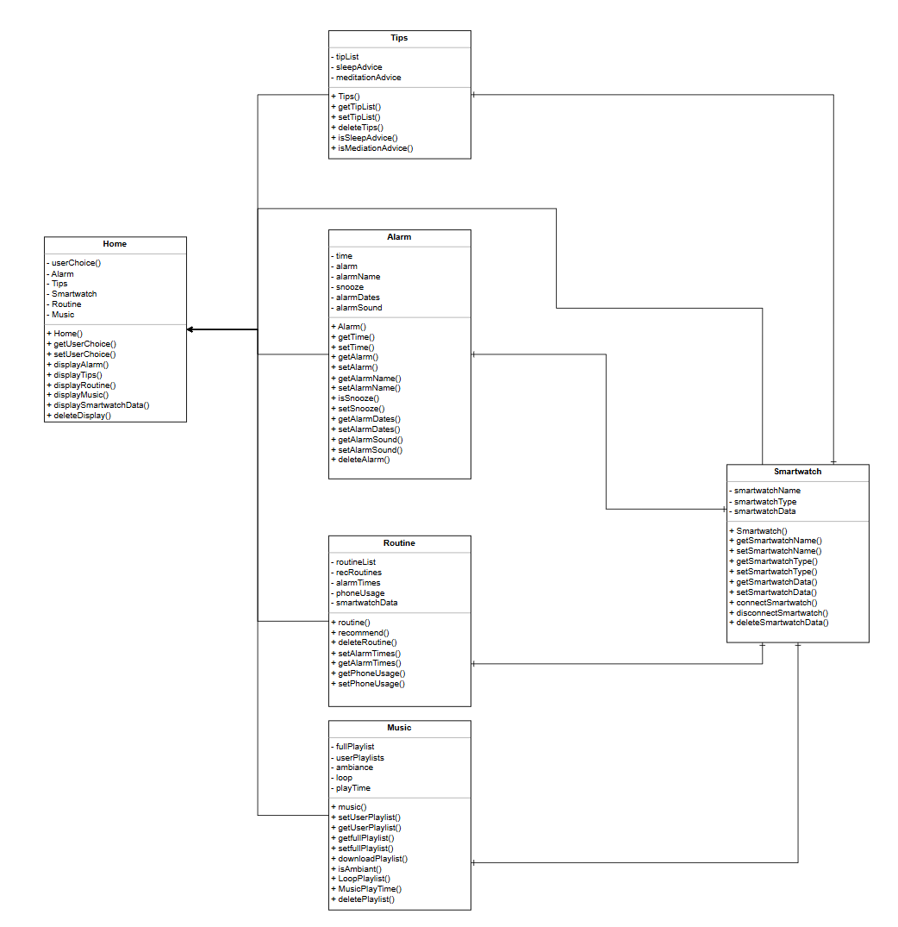

Use Case Diagram (DC)
Here is the ucd

Use Case Scenarios (MC)
Here is the ucdd

System Sequence Charts (DC)
Here is the ssc

